Assignment -2

Exercise -2 on 27.1.21

**Question 1**: Write a command to list all the files inside a folder i.e. if there is a folder inside a folder then it should list all files inside the sub-folder which is inside the folder to be listed.

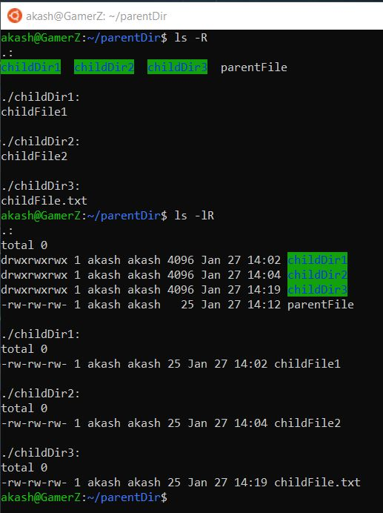

**Question 2**: Create a tree structure named ‘**training**’ in which there are 3 subdirectories – ‘**level 1**’,’ **level2**’ and ‘**cep**’. Each one is again further divided into 3. The ‘level 1’ is divided into ‘**sdp**’, ‘**re**’ and ‘**se**’. From the subdirectory ‘**se**’ how can one reach the **home** directory in one step and also how to navigate to the subdirectory ‘**sdp**’ in one step? Give the commands, which do the above actions?

* Tree structure named ‘**training**’ in which there are 3 subdirectories

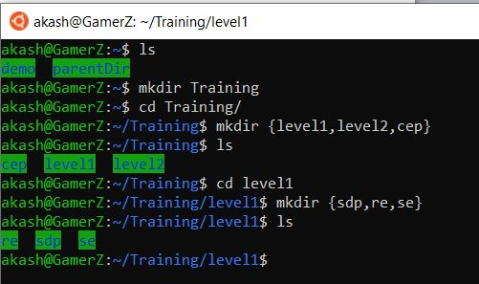

* Navigate from the subdirectory ‘se’ to home directory in one step

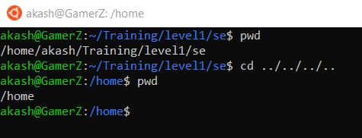

* Navigate from home directory to sdp directory in one step

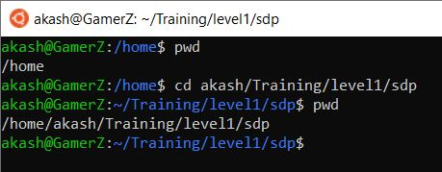

**Question 3:** How will you copy a directory structure dir1 to dir2? (With all the subdirectories)

**Question 4:** What is the command for printing the current time in 24-hour format?

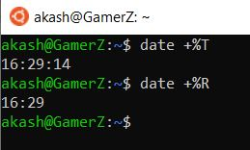

**Question 5:** Create the following structure using unix commands.



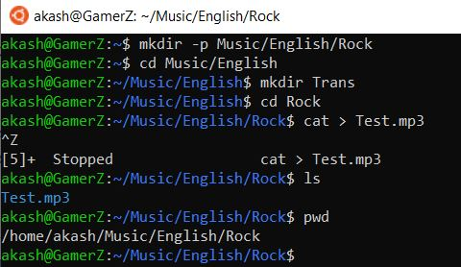

**Question 6:** Suppose that you are in the subdirectory “Rock”. How will you step into the subdirectory “English”? Execute the command using absolute and relative pathnames

**Absolute Path**: cd /home/akash/Music/English

**Relative Path**: cd ..

